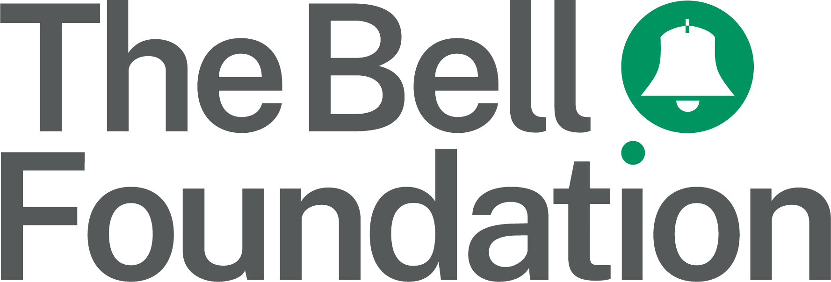
!!
Pupil Pursuit Proforma A: Opportunities for Academic Language Development

Observation details

Observer’s name:

Pupil’s name:

Subject:

Year:

English proficiency level (see below):

Instructions

Fill in the table below using the provided codes to record your observations within timed intervals. See Proforma Sample A for an example. You can use the box on the next page to record any further comments.

English proficiency levels: A: New to English; B: Early acquisition; C: Developing competence; D: Competent; E: Fluent. To find out more about assessing proficiency in English, see: bell-foundation.org.uk/eal-assessment-framework

Time | Listening | Speaking | Reading/Viewing | Writing | Off task/Unable
Time | Social Academic | Social Academic
Minute
1–5
Minute
6–10
Minute
11–15
Minute
16–20
Minute
21–25
Minute 26–30
Codes | T listening to teacher  S listening to student  HL home language | WP word/phrase  CS complete sentence  ED extended discourse  HL home language  T speaking to teacher  S speaking to student | CR choral reading  PR partner reading  GR group reading  HL home language  I independent | CW copy writing  SF sentence frame  HL home language  I independent | UA: unable to comprehend, speak, read, or write [please specify L, S, R or W] without additional support  OT: off task during listening, speaking, reading, or writing [please specify: L, S, R or W]

Record any further comments on observed activities and interactions here:

