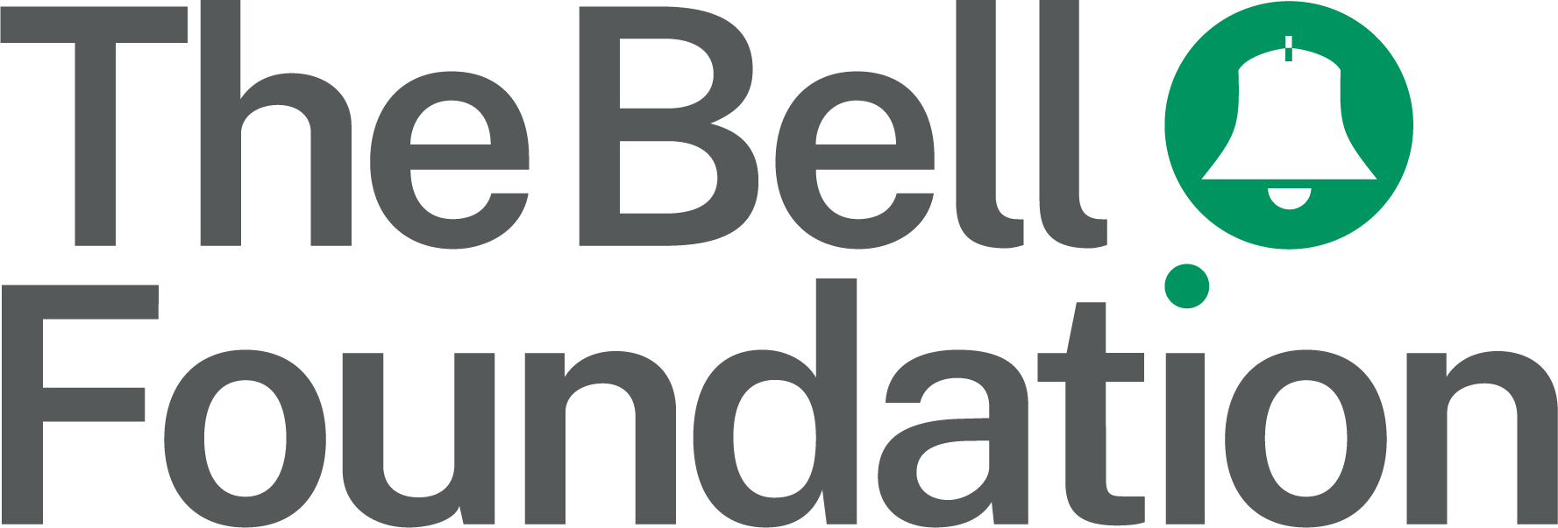
!!
Pupil Pursuit Proforma B: Opportunities for Oral Language Development

Observation details

Observer’s name:

Pupil’s name:

Subject:

Year:

English proficiency level (see below):

Instructions

There are two tables in this proforma. The first is for keeping a tally of spoken language use. In each time interval, every time you observe language use, make a tally mark on the left-hand side of the chart to indicate the context. On the right-hand side of the chart, record the type of language observed using (E) for English and (HL) for home language. Make a tally in the final column every time you observe a missed opportunity for language use.

The table on the second page is for recording any notes or observations within each time interval. See Proforma Sample B for examples.

English proficiency levels: A: New to English; B: Early acquisition; C: Developing competence; D: Competent; E: Fluent. To find out more about assessing proficiency in English, see: bell-foundation.org.uk/eal-assessment-framework

Table 1: Language-use chart
Time | Context |  |  |  | Language use
Time | Speaking to student/s |  | Speaking to teacher |  | Word/  phrase | Complete sentence | Extended discourse | Missed opportunity
 | Social register | Academic register | Social register | Academic register | E = English; HL = home language
Example |  |  |  |  | E |  | HL
Minutes
1–5
Minutes
6–10
Minutes
11–15
Minutes
16–20
Minutes
21–25
Minutes
26–30

Table 2: Additional notes and comments on observed activities and interactions
Time | Context code | Notes/comments
Minutes 1–5
Minutes 6–10
Minutes 11–15
Minutes 16–20
Minutes 21–25
Minutes 26–30
Context codes: SS = student/social; SA = student/academic; TS = teacher/social; TA = teacher/academic

