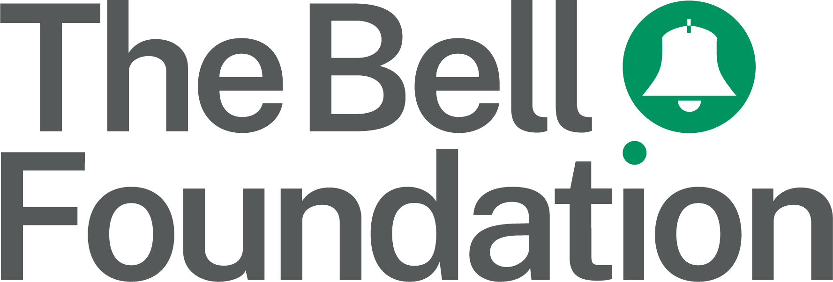
Lesson Observation with an EAL Focus

Instructions

Discuss and agree an overall focus of the observation with the teacher. Example: To assess whether learners who are new to English are able to access lessons in a meaningful way.

Then select up to five specific points to look for during the observation, which will help inform your overall focus. Some suggested points are listed by category in the table below.

On the chart provided, use the category letter and question number to indicate your focus points in the left-hand column. Use the middle column to record your observation, and the right-hand column for any additional notes or comments.

Category | Suggested focus points
A. Learning environment | - Are the preferred languages of multilingual learners valued and celebrated within the classroom?  - Do multilingual learners feel safe to use their preferred language in the learning environment?  - Are the preferred languages of multilingual learners used to support their learning? For example, are:  - Multilingual prompts displayed (e.g., key words);  - Bilingual dictionaries, translation tools, and other resources (e.g., multilingual reading material) available to access?  - Are multilingual learners aware of and confident about established classroom routines?  - Do teachers and peers pronounce multilingual learners’ names correctly?  - Are the efforts of multilingual learners to participate and contribute rewarded and praised?  - Are multilingual learners provided with opportunity to interact with their peers, including those who share the same language?  - Is the classroom environment somewhere that multilingual learners can make and learn from mistakes? How is this evidenced?
B. Lesson structure | - Are the lesson objectives clearly communicated and explained? Is this communication supported by visuals or icons, if needed?  - Is the lesson structure clear for learners who are at different levels of proficiency in English? For example, have the lesson instructions been simplified and graded to ensure they are comprehensible to all?
C. Classroom management | - Are multilingual learners grouped appropriately to support learning e.g.,  - In pairs or groups with confident English speakers?  - With same-first-language pairs or groups?  - In mixed groups?  - Have additional adults:  - Received effective communication from the teacher about their role and responsibilities during the lesson, including providing feedback on pupils’ learning?  - Been informed about learners’ proficiency in English and language targets?  - Been deployed effectively to provide impactful support and encourage independent learning? Does this include adults who share the same language as learners in the class?
D. Teaching | - Does the teacher:  - Know who the multilingual learners are?  - Know what languages are spoken in the class?  - Know the English-language proficiency of each multilingual learner?  - Have an awareness of learners’ prior knowledge or experience of the topic/subject/lesson?  - Do the planned activities take account of learners’ English-language proficiency alongside the curriculum content? Have activities and resources been adapted with appropriate strategies to enable multilingual learners’ access to the curriculum?  - Is there evidence that key vocabulary and concepts are being pre-taught to multilingual learners, to enable them to engage in the lesson?  - Are multilingual learners included and engaged in the planned learning tasks?  - Are multilingual leaners given the opportunity to engage in different types of purposeful talk and active listening in different contexts?  - Are oral, reading, or writing tasks modelled to show expectation?  - Are there appropriate language targets in place that support the progress of learners’ English-language proficiency? Do these inform the lesson plan alongside subject-curriculum content?
E. Learning | - Are questioning strategies adapted for different stages of English-language proficiency to ensure understanding of instructions, vocabulary, and concepts and to encourage a response?  - In what ways are learners given opportunity to demonstrate their understanding of the learning, e.g. using verbal or non-verbal responses, providing thinking time, offering choices?  - Are the learning outcomes representative of learners’ level of English-language proficiency?

Teacher: |  |  | Date: | Observer(s):
Subject: |  |  | Class/Year: | Other adults/support staff:
Lesson context: |  |  |  | Agreed focus of observation:
Focus points  Use category letter and question number (e.g. A3) | Y N N/A  Circle to indicate | Notes
 | Y N N/A
 | Y N N/A
 | Y N N/A
 | Y N N/A
 | Y N N/A

