
My Thoughts About School
Pupil voice proforma (primary)

What is this about?
We want to hear what you think about your school.

We want to know how we can help children who are learning English.

What do I need to do?
Think about the questions below.

Think about how you might answer them. You can write short notes or words to help you remember.

You can write in any language you like.

- This sheet is just for you. Your teachers will not see it.
- There are no right or wrong answers.
- We want to know about your ideas and experiences.

Why are we doing this?
Your school wants to learn more about how it can help multilingual children who are learning English. Your ideas are very important and helpful.


About me
My name:

Question | Answer
What languages do you speak at home?

What is your favourite thing about your culture?

For example, does your family eat special food from your country or culture?

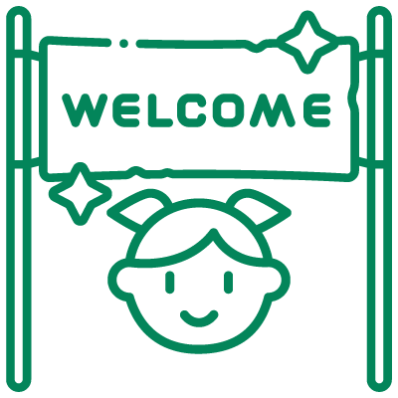
Your first days
Question | Answer
When did you start at this school?

How did you feel when you first started coming to this school?

Who helped you when you were new to the school?

How did they help you?

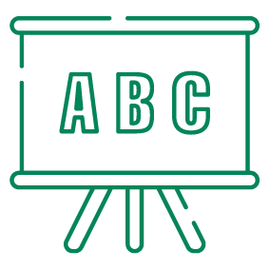
Learning English
Question | Answer
Is learning English easy or hard?

What makes learning English hard?
What helps you to learn English?

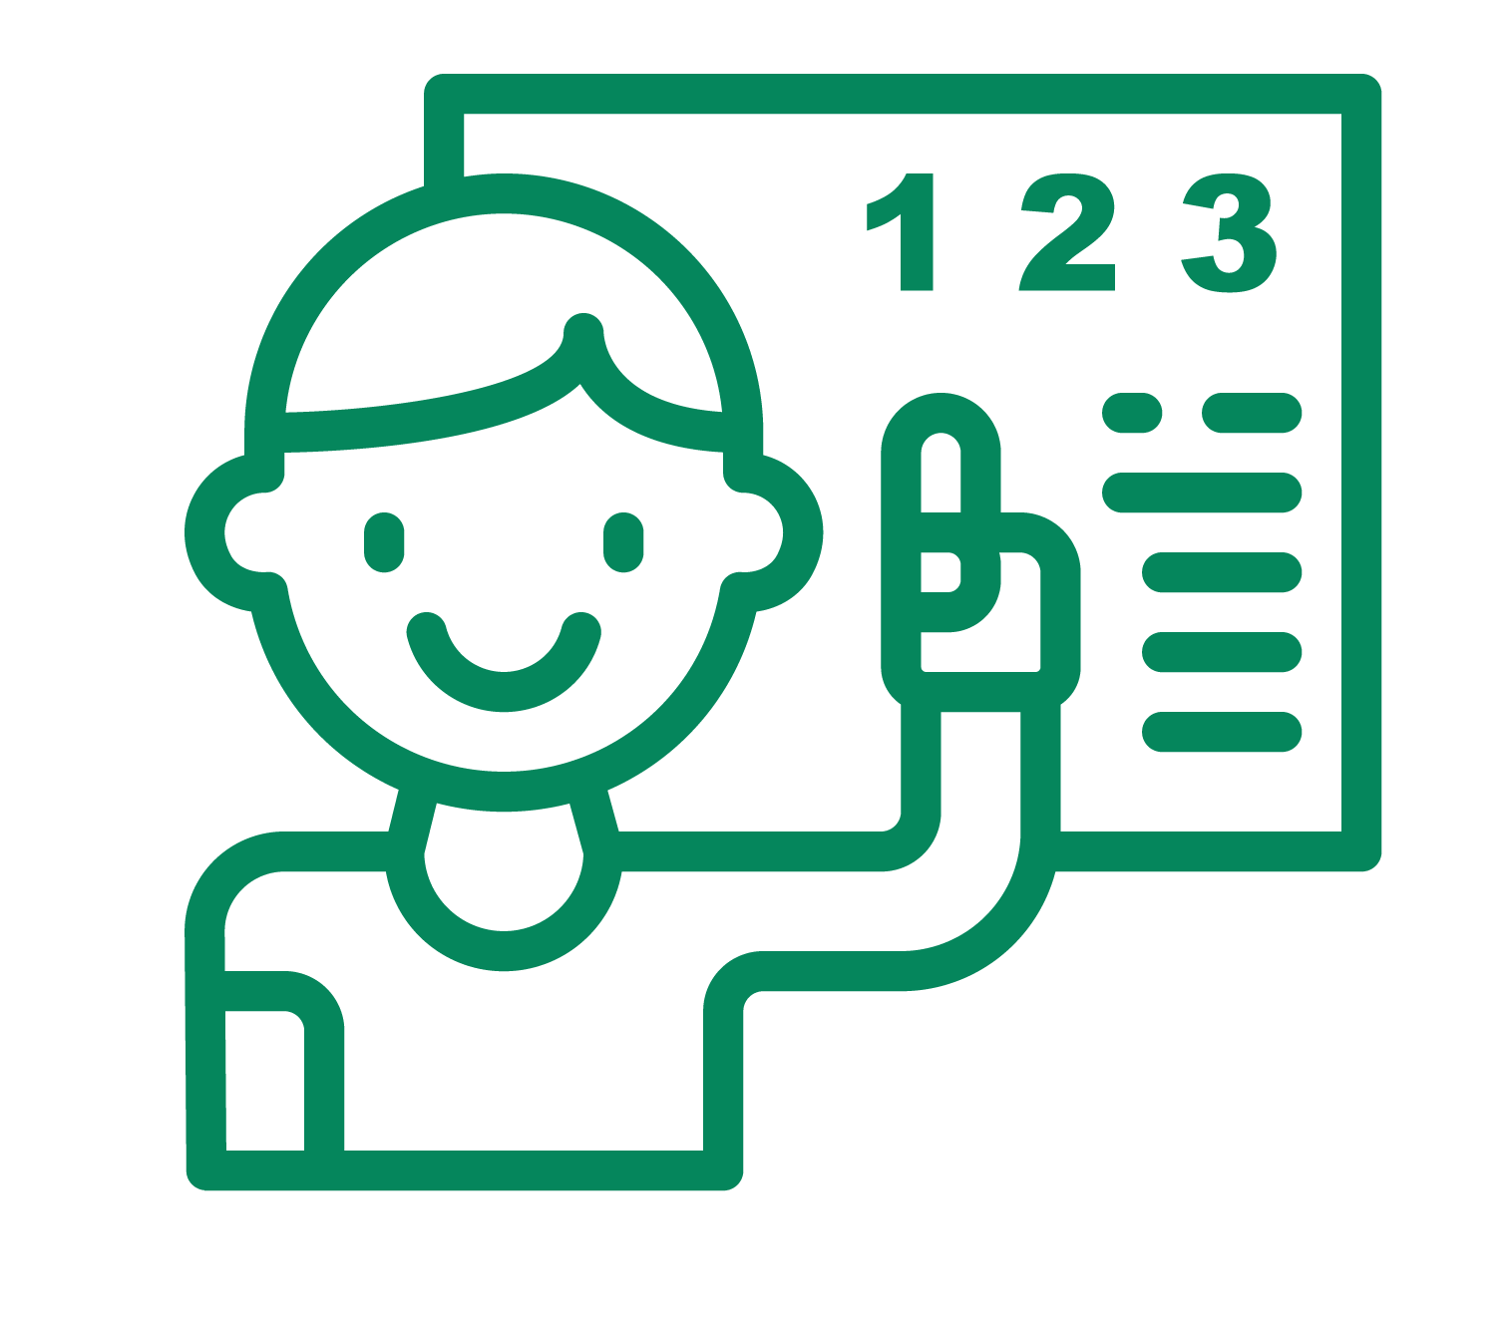
Understanding lessons
Question | Answer
Do you understand your lessons? | Draw a circle around or a line under your answer  If you are using a screen, type an X next to your answer  No  Sometimes  Always

What could teachers do to help you understand your lessons better?


Friends
Question | Answer
Do you have friends at school who speak your home language?

When do you talk with them in your home language?
What helps you make new friends at school?


Last thoughts

Question | Answer
How do you feel now about coming to this school?

Is there anything more you want to tell us?

